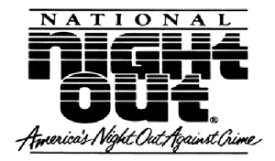
A GOOD NIGHT TO GET TO KNOW YOUR NEIGHBORS
You are invited to Park Plaza’s annual night out against crime!
DATE: August 2nd, 2016
TIME: 6:30pm to 9:00pm
LOCATION: 1260 Onondaga Street (Community Garage)
EVENT SPECIFICS:
- Food and beverage will be provided (feel free to bring a dish to share)
- Some chairs will be provided / feel free to bring your own
- Please let us know that you are coming – 763-486-7339

National Night Out is an annual event designed to strengthen our communities by encouraging neighborhoods to engage in stronger relationships with each other and with their local law enforcement partners.
A fun night to sit and chat with others, for kids to play together and to just create great new memories.

